Probl rezolvate – lab 7

1. A string of words is given. Create two new other strings: L – string of low bytes from each word from s and H – string of high bytes from each word from s.

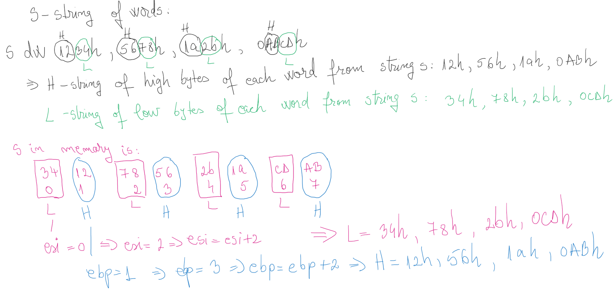

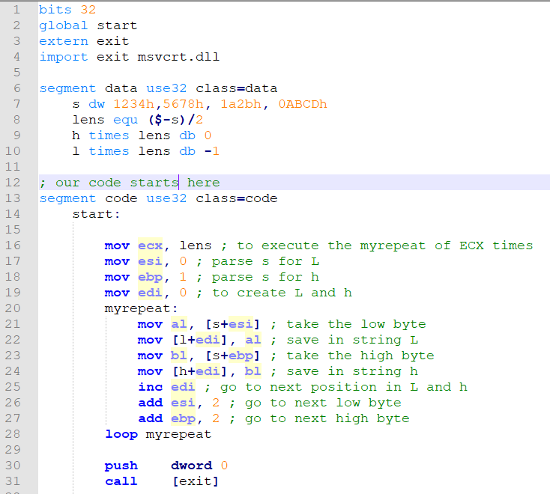

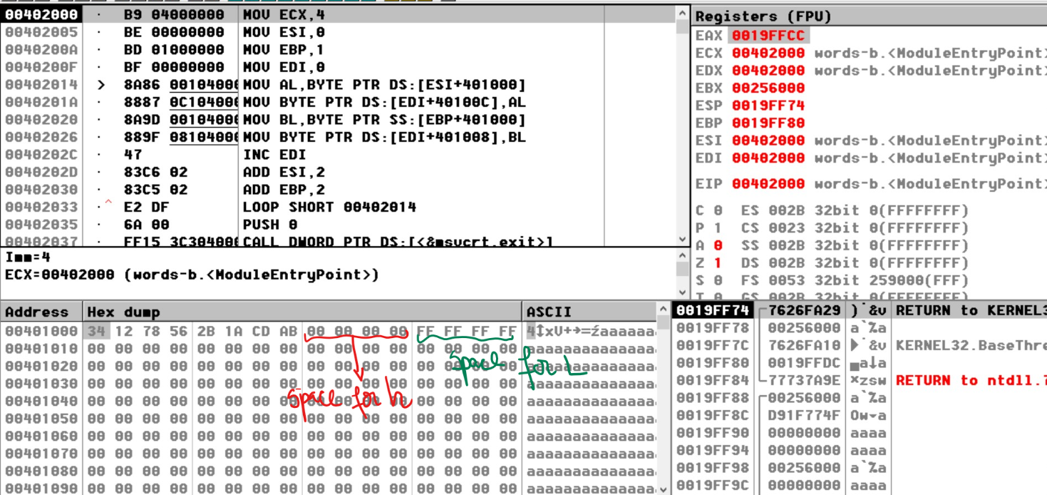

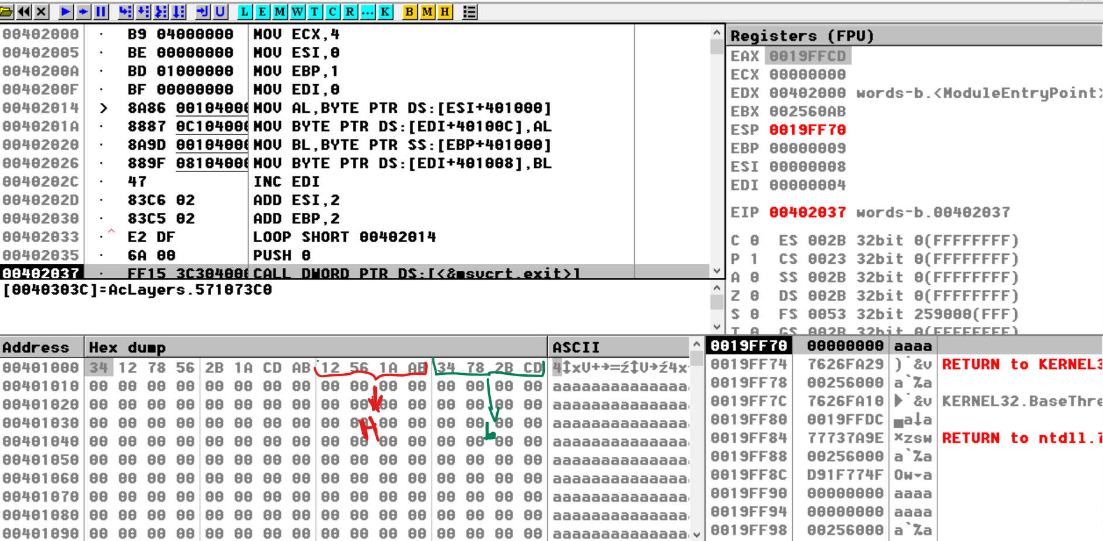

2. A string of doublewords is given.

Copy in string d only doblewords from even position from strings.

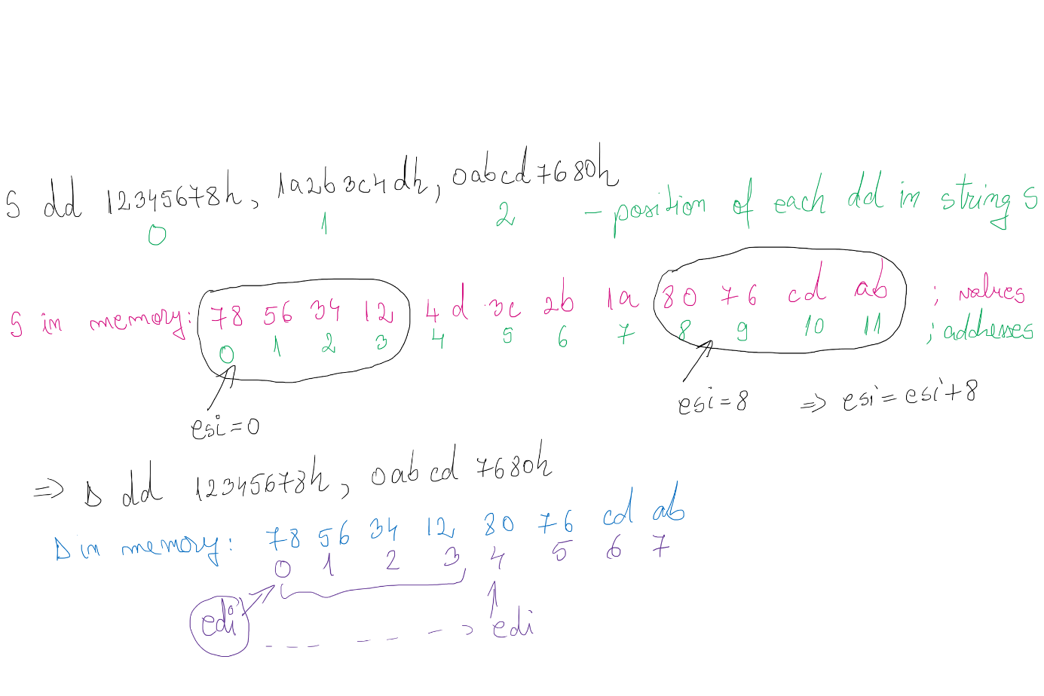

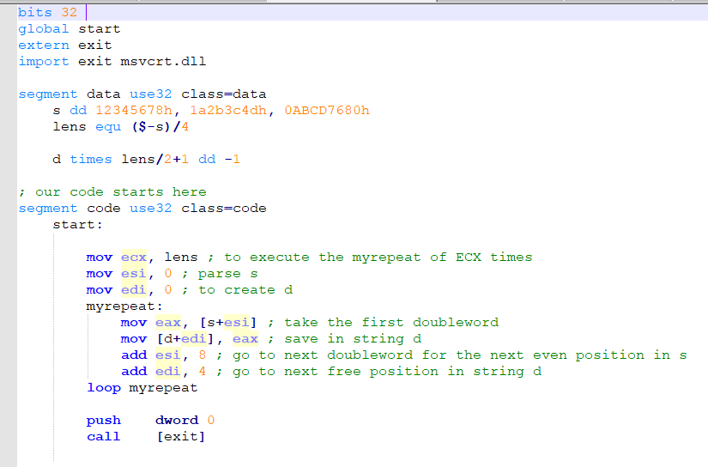

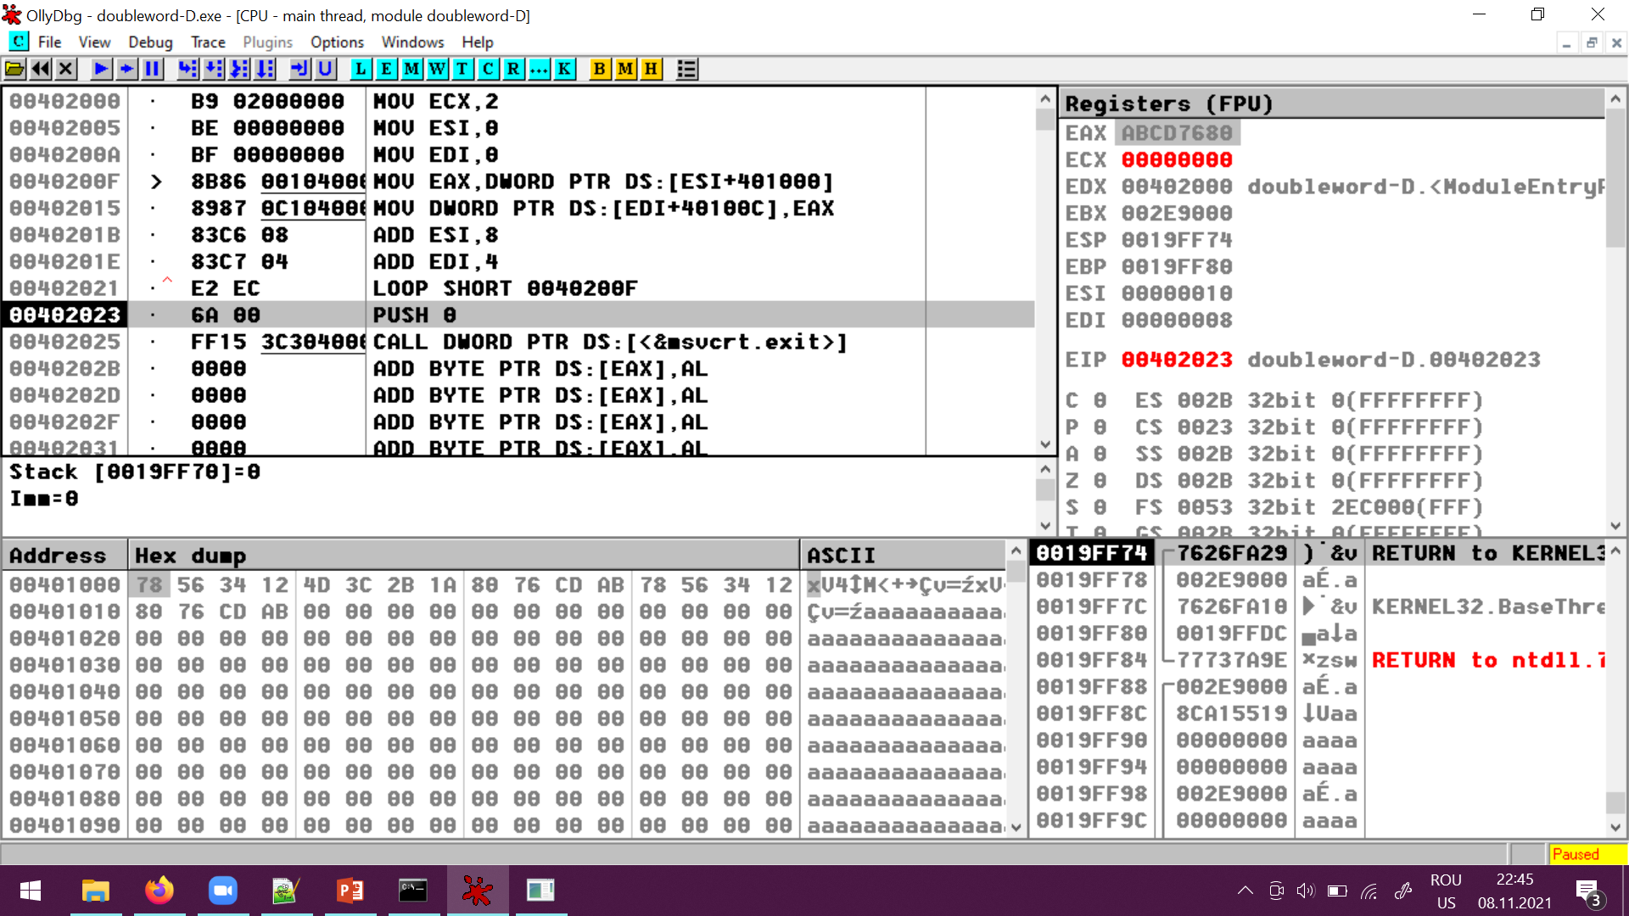

A string of quadwords is given.

Save in D (string of quadwords) only the quadwords from S with an odd number of setted bits (bits with value 1 in binary)

doar quadwordurile cu nr impar de biti setati

